Student: Brian Johnston

Class COP 2362

Assignment 5-4

Print screen:

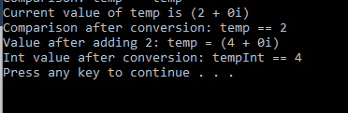

Code:

public static bool operator !=(Complex lhs, Complex rhs)

{

return !(lhs.Equals(rhs));

}

//Verifies the type of the param is actually a Complex object

public override bool Equals(object obj)

{

if (obj is Complex)

{

Complex compare = (Complex)obj;

return (this.Real == compare.Real) && (this.Imaginary == compare.Imaginary);

}

else

{

return false;

}

}

public override int GetHashCode()

{

return base.GetHashCode();

}

}

}